**AI for the Arts – Intro Lecture**

Early Influences:

* Aristotle (c. 384-322 BCE) formulated laws governing the rational mind.
* Ramon Lull (c. 1232-1315) devised a “machine” of paper wheels as a system with which to reason.
* Thomas Hobbes (1651) in his book *Leviathan*, talked of “artificial animals”.
* René Descartes (1596-1650) on rationalism, Francis Bacon (1561-1626) and John Locke (1632-1704) on empiricism, David Hume (1711-1776) and Immanuel Kant (1785) on induction, and Ludwig Wittgenstein and Bertrand Russell on logical positivism, Jeremy Bentham (1832) and John Stuart Mill (1863) on utilitarianism.
* Formal logic of George Boole (1815-1925) and Gottlob Frege (1848-1925) led to first order logic which is a bedrock of earlier knowledge systems.
* Probability theory of Gerolamo Cardano (c. 1501-1576) and Blaise Pascal (c. 1623-1662) and later the rules of Thomas Bayes (c. 1702-1761) form a crucial tool for AI.
* Some popular machine learning algorithms such as linear regression was first used for predicting planetary motions by Adrien-Marie Legendre (c. 1752-1833 and Karl Friedrich Gauss (1777-1855), the term being coined by Francis Galton in 1886.

Defining the Field

“The field of artificial intelligence, or AI, is concerned with not just understanding but also building intelligent entities – machines that can compute how to act effectively and safely in a wide variety of novel situations.”

Understand learning, reasoning, and perception while achieving specific objectives such as playing chess, proving mathematical theorems, writing poetry, driving a car, diagnosing disease.

Tackle a variety of tasks such as describing what’s happening in a video, question answering, robots operating in a factory, real time translation, visual recognition of objects, optimisation of investment and trading, and voice/speech recognition.

Russel and Norvig (2022) “Artificial Intelligence: A Modern Approach”.

Measuring Intelligence

Artificial Narrow/Weak Intelligence – AI trained to perform specific tasks.

Artificial General/Strong Intelligence – trained to learn any task or at least a wide variety of tasks and/or “where a machine would have an intelligence equal to humans; it would have a self-aware consciousness that has the ability to solve problems, learn, and plan for the future”.

Artificial Super Intelligence – “Would surpass the intelligence and ability of the human brain”.

Disentangling Terminology



History in One Slide

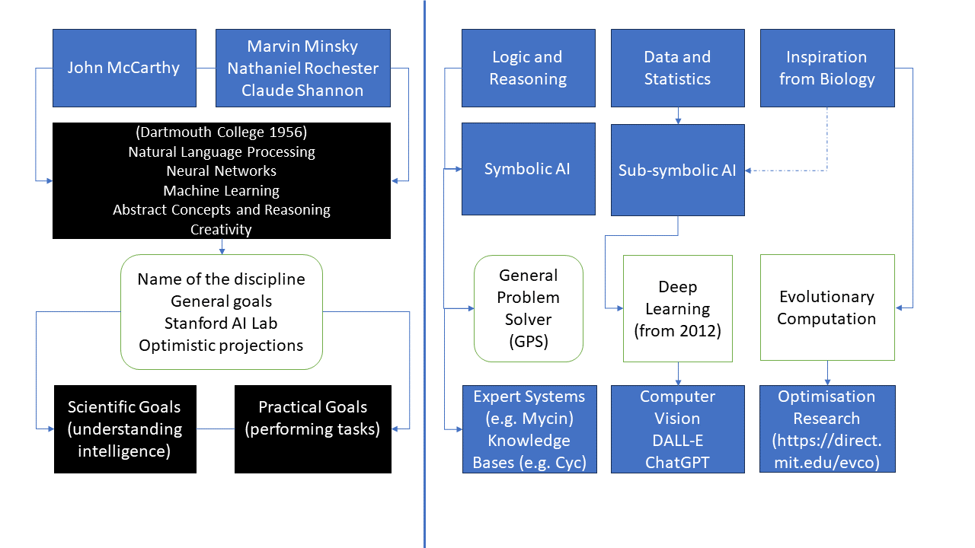

AI Winters



Enter Turing and Asimov

The “standard interpretation” of the Turing test, in which player C, the interrogator, is given the task of trying to determine which player – A or B – is a computer and which is a human. The interrogator is limited to using the responses to written questions to make the determination.

The fictional ‘Handbook of Robotics, 56th Edition, 2058 AD” referenced in the story “Runaround” from I. Robot:

* The first law – A robot may not injure a human being or, through inaction, allow a human being to come to harm.
* The second law – A robot must obey the orders given it by human beings except where such orders would conflict with the first law.
* The third law – A robot must protect its own existence as long as such protection does not conflict with the first or second law.

Early Artificial Neural Networks

“McCulloh – Pitts neuron” the first mathematical model of a neural network.

Minsky also built, in 1951, the first randomly wired neural network learning machine, SNARC.

Rosenblatt was best known for the perceptron, an electorin device which was constructed in accordance with biological principles and showed an ability to learn.

Games and AI

Deep Blue’s victory is considered a milestone in the history of artificial intelligence and has been the subject of several books and films.

AlphaGo Master v Tang Weixing (31 December 2016). AlphaGo won by resignation. White 36 was widely praised.

Ken Jennings faces off against supercomputer Watson and his fellow champion Brad Rutter.

AI Chat Agents

ELIZA is an early natural language processing computer program created from 1964 to 1967 at MIT by Joseph Weizenbaum.

The Loebner Price awarded prizes to the computer programs considered by the judges to be the most-human like. The prize is reported as defunt since 2020. A.L.I.C.E won multiple times (2000-2004).

Tay released by Microsoft in 2016. Bot began to post inflammatory and offensive content. Shut down only 16 hours after its launch.

Increasing Interest in Responsible AI

* Lethal autonomous weapons.
* Surveillance and persuasion.
* Biased decision making.
* Impact on employment.
* Safety-critical applications.
* Cybersecurity.
* Impact on climate change and sustainability.
* Rise of EU AI Act, Scottish AI Register, AI auditing frameworks. Taxonomies of risks and harms.